Experiment 9
Setting Up a Wireless Network
Lab Objective:
To configure and verify both IPv4 and IPv6 addressing on wireless network devices like routers, switches, access points, and client devices (PCs/laptops).

What is a Wireless Network?
A wireless network allows devices to stay connected to the network without physical cables. It uses radio frequency (RF) waves to connect devices like laptops, mobile phones, or desktops to the internet and internal networks.
Key components:
- Wireless Router / Access Point (AP)
- Client Devices (like laptops, smartphones)
- SSID (Service Set Identifier) – the network name
- Security Protocols – WPA2/WPA3

🔹 What is IP Addressing?
IP addressing is used to uniquely identify devices on a network. It enables communication between devices.
IPv4 Address:
- 32-bit address, written in dotted decimal format (e.g., 192.168.1.1)
- Consists of Network ID and Host ID
- Divided into Classes (A, B, C) or Private/Public ranges
IPv6 Address:
- 128-bit address, written in hexadecimal colon-separated format (e.g., 2001:0db8:85a3::8a2e:0370:7334)
- Supports vast number of addresses (2^128)
- Eliminates the need for NAT
- More secure and efficient

Steps to Configure IPv4 and IPv6 Addressing
1. Set Up Wireless Router / Access Point
- Access the router through its default IP (192.168.0.1 or 192.168.1.1)
- Set SSID (network name) and password
- Enable DHCP for automatic IPv4 assignment
- Configure IPv6 if supported by the device (Static or SLAAC)
2. Configure IPv4 on Client Device
- Go to Network Settings on the PC/laptop
- Select the wireless network and connect using the password
- If using manual IPv4 configuration:
  - IP address: 192.168.1.10
  - Subnet mask: 255.255.255.0
  - Gateway: 192.168.1.1
  - DNS: 8.8.8.8
3. Configure IPv6 on Client Device
- If automatic, the system will get an address via SLAAC or DHCPv6
- If manual:
  - IPv6 address: 2001:db8:abcd:001::1
  - Prefix length: 64
  - Default gateway: 2001:db8:abcd:001::ff
  - DNS: 2001:4860:4860::8888

Verification Commands
On Windows Command Prompt:
ipconfig /all
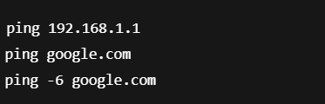
- Shows IPv4 and IPv6 addresses assigned.

- Verifies connectivity for both IPv4 and IPv6
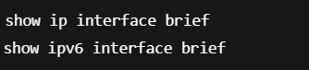
On Router (via CLI like Cisco IOS):

- Displays configured Ips
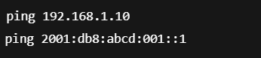
Important Configuration Commands (Cisco Router Example)
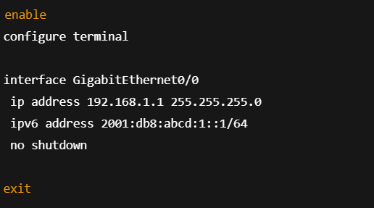
Conclusion / Outcome:
By the end of this experiment, you should be able to:
- Set up a basic wireless network.
- Configure and assign both IPv4 and IPv6 addresses.
- Verify IP configurations using commands.
- Understand the differences between IPv4 and IPv6.
- Ensure network connectivity and proper address assignment.

